Question :1
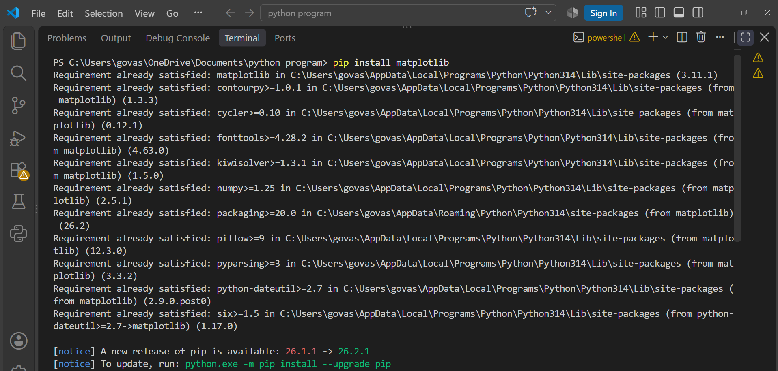
Install Matplotlib in your Python environment and create a simple line plot showing the number of daily steps you took over the last 7 days. Save the chart as steps_lineplot.png :
import matplotlib.pyplot as plt
days =["Mon","Tue","Wed","Thu","Fri","Sat","Sun"]
steps =[4500,6200,7100,5800,8000,9500,7000]
plt.plot(days,steps,marker="o")
plt.xlabel("Days")
plt.ylabel("Number of Steps")
plt.title("Daily Steps for 7 Days")
plt.savefig("steps_lineplot.png")
plt.show()
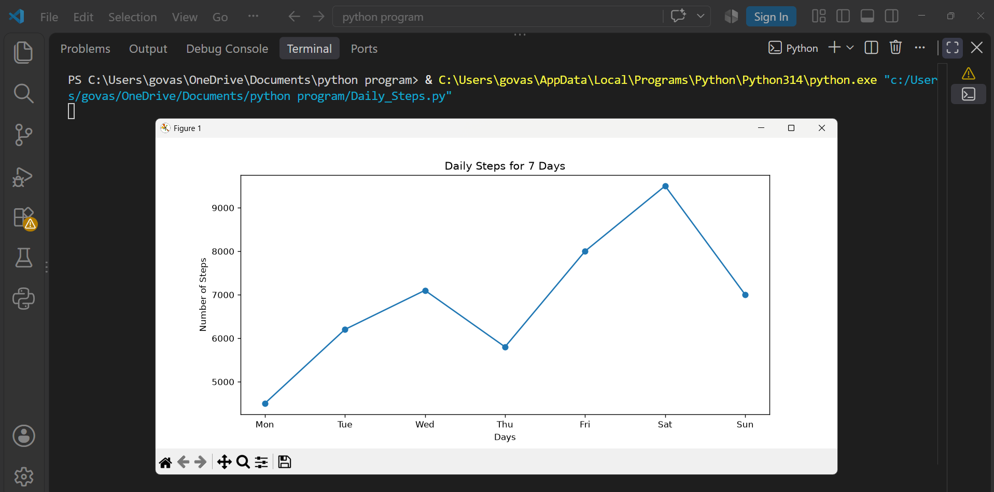

Question : 2
Using Matplotlib, create a scatter plot of 10 restaurants from your city with their Zomato ratings on the x-axis and average meal price on the y-axis. Add axis labels and a title to the chart :
import matplotlib.pyplot as plt
restaurants =[
"Restaurant 1", "Restaurant 2", "Restaurant 3", "Restaurant 4",
"Restaurant 5", "Restaurant 6", "Restaurant 7", "Restaurant 8",
"Restaurant 9", "Restaurant 10"
]
ratings =[3.5,4.0,4.2,3.8,4.5,3.2,4.1,3.9,4.3,3.7]
price =[300,500,700,450,900,250,600,400,800,350]
plt.scatter(ratings,price)
plt.xlabel("Zomato Rating")
plt.ylabel("Average Meal Price (₹)")
plt.title("Restaurant Ratings vs Average Meal Price")
plt.show()
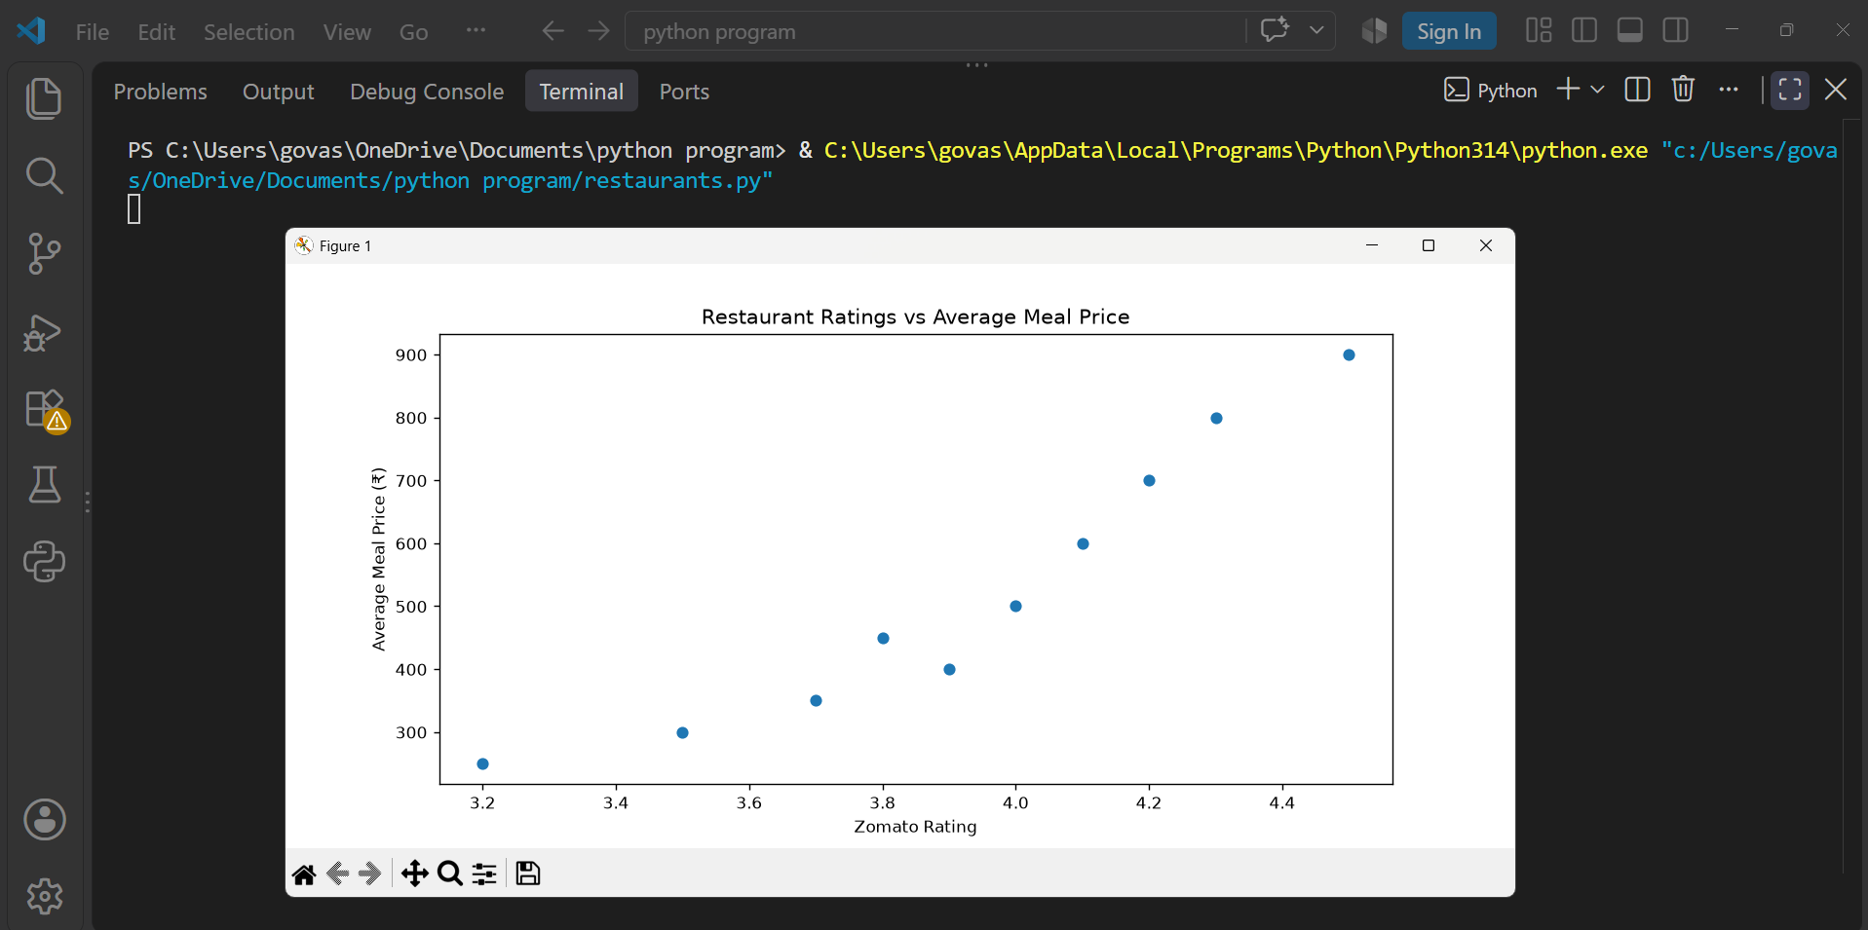

Question : 3
Build a bar chart that shows the number of orders you or your friends placed on Swiggy, Zomato, and Domino’s in the last month. Use different colors for each bar and add a legend :
import matplotlib.pyplot as plt
platforms =["Swiggy","Zomato","Domino's"]
orders =[12,9,6]
colors =["red","orange","blue"]
plt.bar(platforms,orders,color=colors,label="Orders")
plt.xlabel("Food Platforms")
plt.ylabel("Number of Orders")
plt.title("Food Orders in Last Month")
plt.legend()
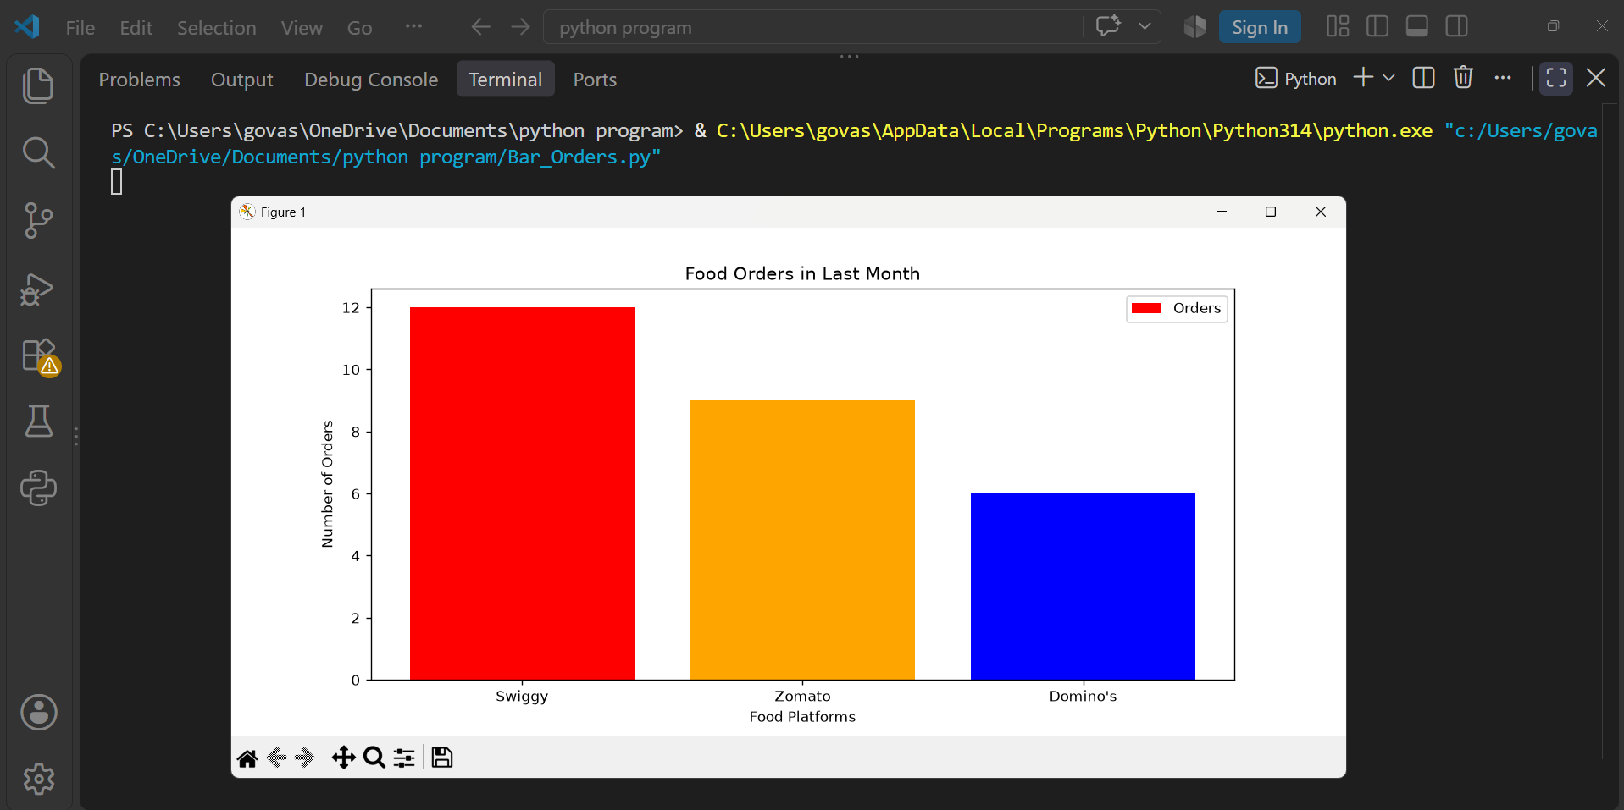
plt.show()
Question : 4
Create a histogram of the durations (in minutes) of your last 20 Spotify listening sessions using Matplotlib. Set the number of bins to 5 and customize the color of the bars :
import matplotlib.pyplot as plt
durations =[15, 22, 30, 18, 25,
40, 35, 20, 28, 45,
32, 17, 50, 27, 38,
42, 24, 31, 19, 36
]
plt.hist(durations,bins=5,color="purple")
plt.xlabel("Duration (Minutes)")
plt.ylabel("Number of Sessions")
plt.title("Spotify Listening Session Durations")
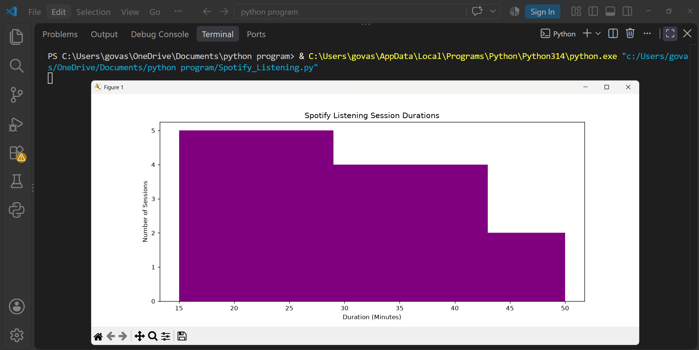
plt.show()
Question : 5
Customize a Matplotlib figure by creating a plot with two subplots: one line plot showing your daily Instagram screen time for a week, and one bar chart showing the number of posts you liked each day. Add appropriate titles, axis labels, and save the figure as social_media_usage.png.<br><br><em><strong>Hint:</strong> Use plt.subplots() to create multiple axes in one figure : </em>

import matplotlib.pyplot as plt
days = ["Mon","Tue","Wed","Thu","Fri","Sat","Sun"]
screen_time = [2.5,3,2,3.5,2.8,4,3.2]
liked_posts = [20,25,15,30,22,35,28]
fig, axes = plt.subplots(1, 2, figsize=(10, 4))

# Line Plot
axes[0].plot(days, screen_time, marker="o")
axes[0].set_title("Daily Instagram Screen Time")
axes[0].set_xlabel("Days")
axes[0].set_ylabel("Screen Time (Hours)")

# Bar Chart
axes[1].bar(days, liked_posts, color="green")
axes[1].set_title("Instagram Posts Liked")
axes[1].set_xlabel("Days")
axes[1].set_ylabel("Number of Posts")
plt.tight_layout()
plt.savefig("social_media_usage.png")
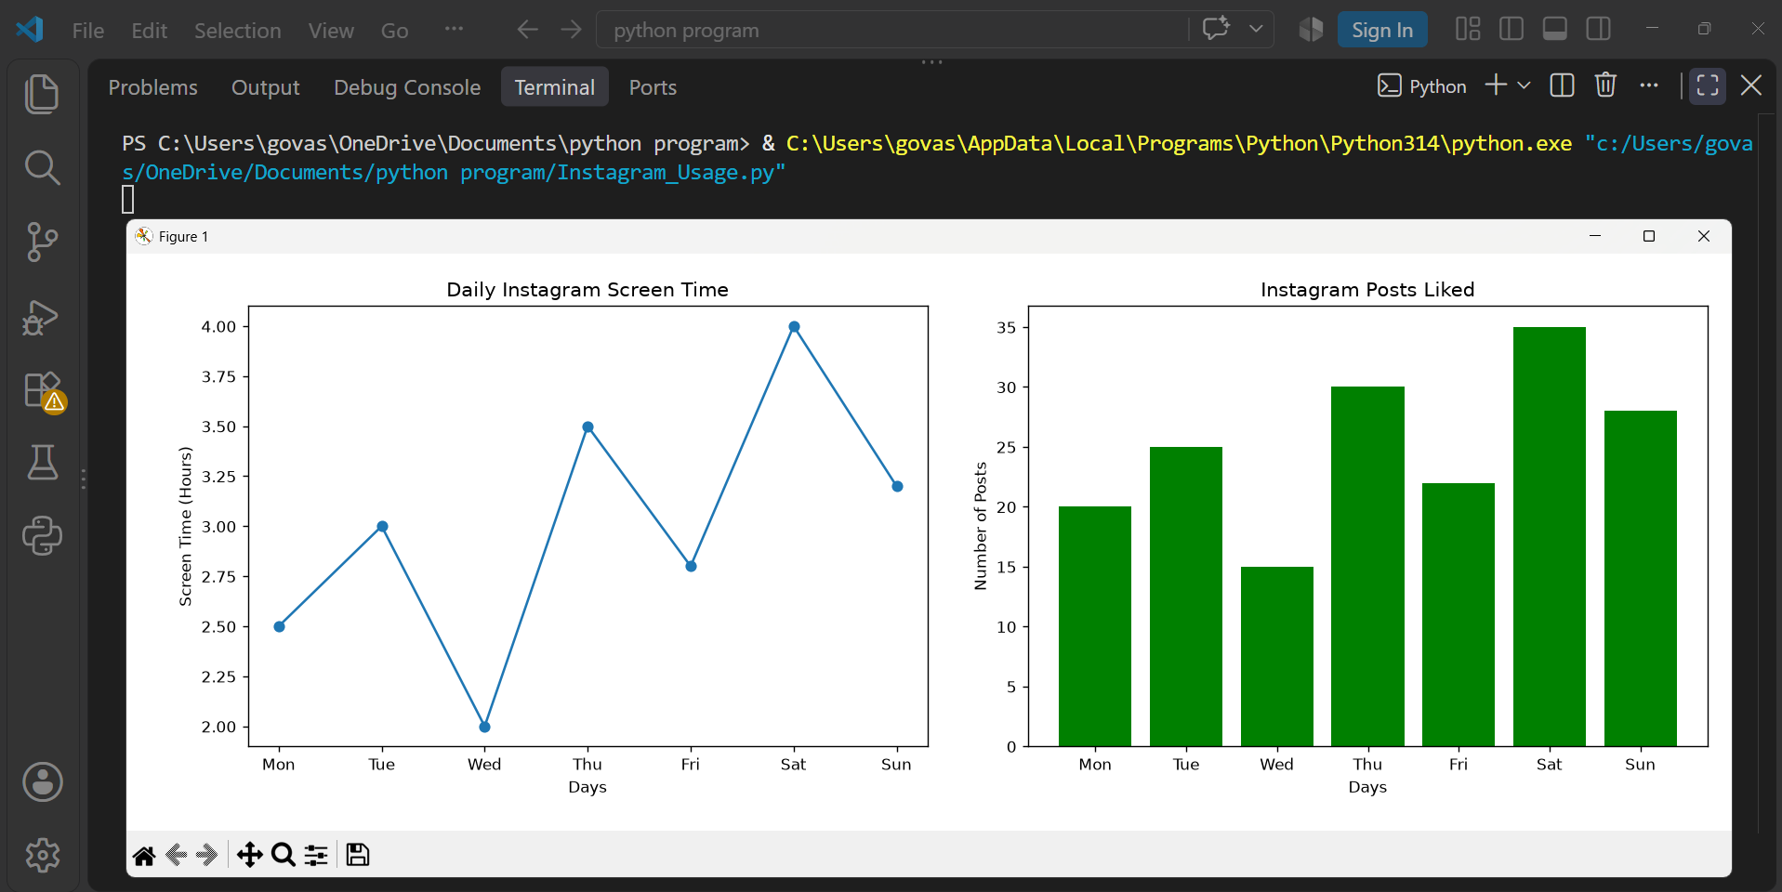
plt.show()

